

Project Report

Email Spam Detection

NAME | Dur Muhammad Khan (fa23-bai-012)
COURSE | Machine Learning
SUBMISSION DATE | 08/12/2025
SUBMITTED TO | Dr. Gulmina Rextina

DEPARTMENT OF COMPUTER SCIENCE

1️⃣ Problem Definition
Emails are an essential communication tool, but spam emails cause inconvenience and security risks.
Objective: Build a machine learning system to classify emails as spam (1) or ham (0) using a self-prepared dataset (spam.csv). The project demonstrates understanding of data preprocessing, feature extraction, model training, evaluation, and interpretation.

2️⃣ Data Acquisition
- Dataset: spam.csv (From Kaggle)
- Number of samples: 5575
- Original Columns:
  - v1 → Original label (spam/ham)
  - v2 → Email text
  - Unnamed: 1, Unnamed: 2, Unnamed: 3 → Extra/empty columns
- Preprocessing:
  - Removed unused columns (Unnamed: 1–3)
  - Created new column spam → 0 = Ham, 1 = Spam
  - Renamed v1 → Category, v2 → Message

3️⃣ Data Preprocessing
- Checked for missing values; none found in Message or Category.
- Cleaned text: lowercasing, removing punctuation and special characters.
- Feature extraction:
  - Naive Bayes: CountVectorizer → email text → word counts
  - Logistic Regression: CountVectorizer → email text → word counts
  - Decision Tree: CountVectorizer → email text → word counts
- Train-test split: 80% training, 20% testing

4️⃣ Model Selection
- Algorithms:
  - Multinomial Naive Bayes (NB)
  - Logistic Regression (LR)
  - Decision Tree (optional)
Justification:

5️⃣ Model Training & Evaluation

5.1 Naive Bayes
Metric | Train | Test
Accuracy | 0.993 | 0.98
Precision | 0.98 | 0.97
Recall | 0.96 | 0.93
F1-Score | 0.97 | 0.95

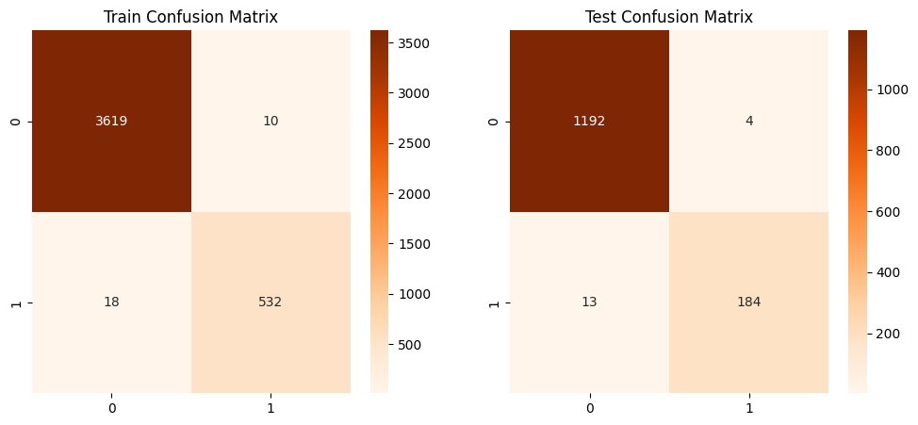

5.2 Logistic Regression
Metric | Train | Test
Accuracy | 0.99 | 0.98
Precision | 1.000 | 0.98
Recall | 0.98 | 0.88
F1-Score | 0.99 | 0.92

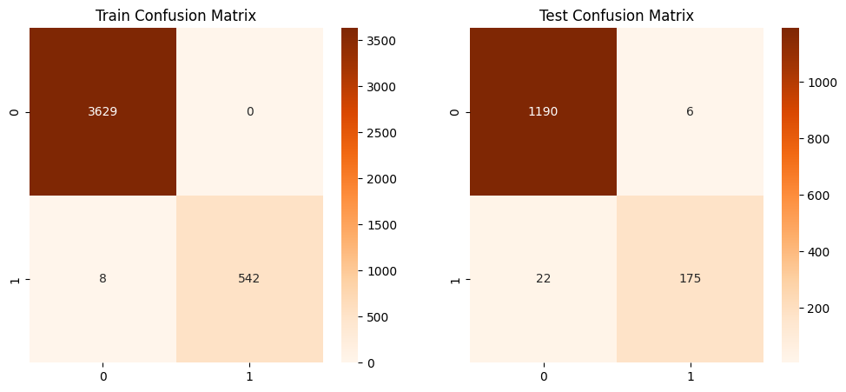

5.3 Decision Tree (Optional)
Metric | Train | Test
Accuracy | 1 | 0.96
Precision | 1 | 0.85
Recall | 1 | 0.83
F1-Score | 1 | 0.85
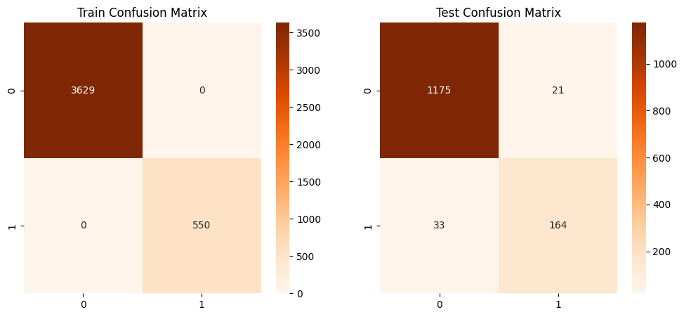
Visuals included:
- WordCloud of most frequent words in Spam and Ham emails
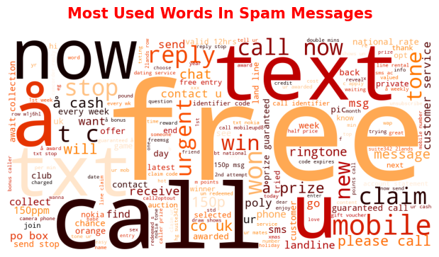
- Confusion Matrix for test data
- Class Distribution Pie Chart (Ham vs Spam)
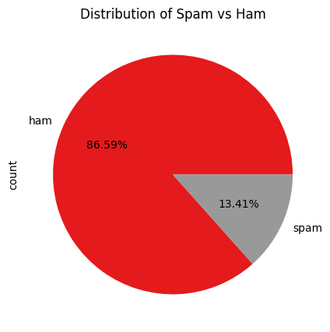

6️⃣ Results Discussion
- High overall accuracy (>97%) on test set.
- Spam detection slightly weaker than Ham (lower recall) due to class imbalance.
- NB works well with count features; LR with TF-IDF captures important words.
- Decision Tree gives interpretable rules but may slightly overfit.

7️⃣Front-End Implementation
To make the spam detection system user-friendly, a simple web interface was created using HTML, CSS, and Flask.

Workflow
- HTML & CSS:
  - Created a simple form where users can enter email text.
  - CSS styling added for buttons, input fields, and layout to make it visually appealing.
- Flask (Python Web Framework):
  - Flask routes handle user input from the form.
  - The input email is passed to the trained machine learning model (Naive Bayes / Logistic Regression).
  - Prediction is returned and displayed on the web page as “Spam” or “Ham”.

Example Workflow:
- User opens the web page.
- Enters email text into the input box.
- Clicks “Check Email” button.
- Flask backend processes the text using CountVectorizer and trained NB model.
- Result displayed:
  - "This is a Spam Email!" or "This is a Ham Email!"

Front-End Advantages:
- Demonstrates real-world application of the ML model.
- Allows non-technical users to interact with the system.
- Makes the project end-to-end, from data collection to deployment.
Output
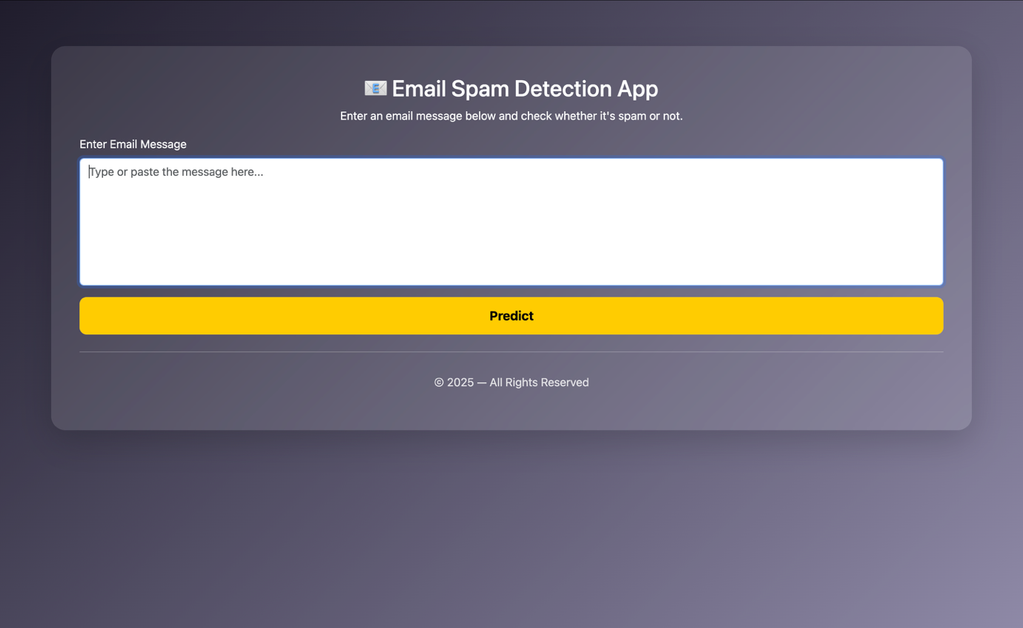
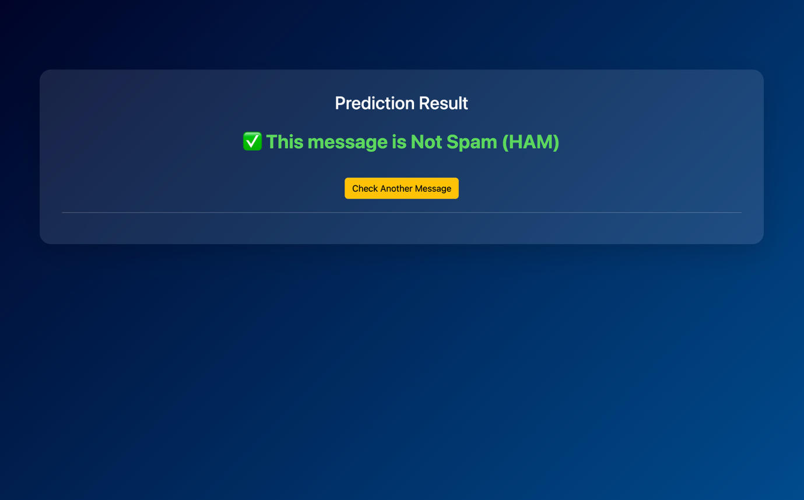

8️⃣ Reflection / Limitations
- Strengths: High accuracy, simple pipeline, easy to use for new emails
- Limitations:
  - Spam recall could improve using class weights or more samples
  - Only text features used; email metadata (sender, attachments) ignored
  - More advanced NLP (embeddings) could further improve performance

8️⃣ Conclusion
- Successfully demonstrates full ML workflow: problem → data → preprocessing → feature extraction → model training → evaluation → interpretation.
- System can classify new emails as spam or ham effectively.
- Visuals and metrics improve understanding of model performance.

9️⃣ References
- Spam dataset (spam.csv) – self-prepared
- Scikit-learn Documentation: https://scikit-learn.org/stable/documentation.html
- WordCloud Library: https://amueller.github.io/word_cloud/

